*May 8th, 2018*

**Algorithms for traffic assignment**

**0 introduction**

In this paper, we try to intuitively display the traffic assignment process of several assignment algorithms commonly used in the O-D estimation. The whole paper is organized in the following manner. Sec. 1 introduces the traffic assignment problem to be solved and general notations. In Sec.2 three assignment rules(i.e., three algorithms) are conducted and their gap perceived in every iteration are compared. Sec. 3 illustrates the assignment process taking Braess network as an example with the Solver function in spreadsheet.

**1 Problem description**

The network in Figure 1 includes two paths connecting the origin and destination, which are arterial and freeway, respectively. Each path is composed of one link. Link 1 represents the freeway, and link 2 is arterial.

Freeway

O

D

Arterial

Figure 1 The traffic network including two paths

Table 1 lists general notations appeared in the traffic assignment problem.

Table 1 Notations and definition

|  |  |
| --- | --- |
| **Notations** | **Definition** |
|  | Set of links in the transportation network |
|  | Index of links in |
|  | The free flow travel time on link  (min) |
|  | The capacity on link  (vehicles/hour) |
|  | The traffic demand from origin to destination |
|  | The traffic flow on link |
|  | The parameter in link cost function, set |
|  | The parameter in link cost function, set |

The assignment is carried out using BPR link cost function

 (1)

In this problem, let , , ,, .

**2 Algorithms**

**2.1 Equilibrium assignment**

The equilibrium link flow pattern can be obtained by solving the flowing mathematical program:

 (2a)

 (2b)

 (2c)

The F-W algorithm is one of the efficient algorithms to solve the above program. Since this network to be solved in this paper is simple, the travel time on both two links can be obtained by the link cost function (1) given the flow on freeway. The flow on the arterial equals the total demand minus the freeway flow. The freeway flow is set from 0 to 7000 and the interval is 200. The variation of travel time on freeway and arterial with the change of freeway flow can be shown as the Figure 2.

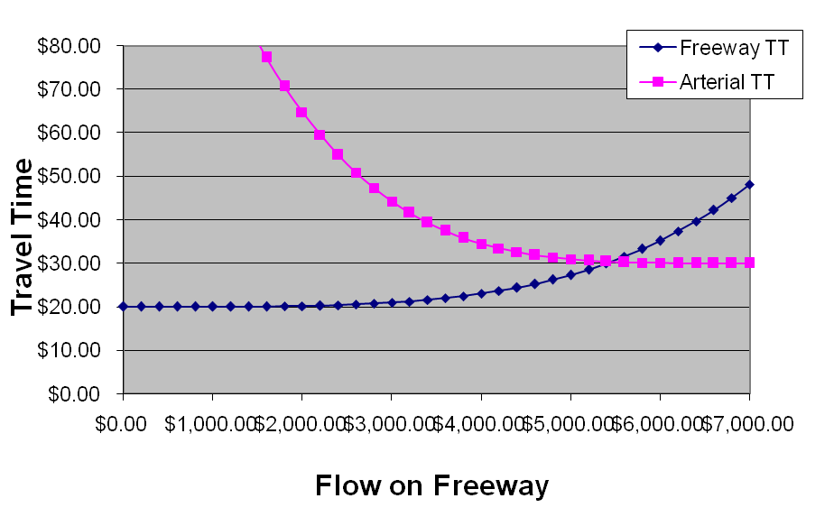

Figure 2 The variation of travel time on two links with the change of freeway flow

At the equilibrium point, the travel time on all used paths is equal and less than all unused paths. In other words, the intersection of two curves in Figure 2 is the equilibrium point, where , , , , and the gap of travel time on both links is . The concrete calculation process can refer to the spreadsheet named "equilibrium".

The meaning of each column in the "equilibrium" spreadsheet is shown in Table 2 (The letters in the parentheses represents the column number, the same below).

Table 2 The meaning of each column in the "equilibrium" spreadsheet

|  |  |  |  |
| --- | --- | --- | --- |
| **Column name** | **Meaning** | | **Calculation** |
| Freeway Flow (E) | The flow on freeway | Predetermined | |
| Freeway TT (F) | The travel time on freeway | Cost function (1) | |
| Arterial TT (G) | The travel time on arterial | Cost function (1) | |
| Gap (H) | The abstract value of difference between travel time on freeway and arterial | Abs (F-G) | |

**2.2 Gradient projection method**

**The algorithm description**

To describe the gradient projection method, a transformation is made for the static assignment user equilibrium program (2). We express the shortest path flows in terms of other path flows. The formula (2b) becomes:

 (3)

The standard optimization problem can be restated as:

 (4a)

subject to  (4b)

where is the new objective function and is the set of non-shortest path flows between all the O-D pairs.

The gradient of the objective function written in terms of the non-shortest path variables can be found using:

 (5)

which results from the definition of . In the case of equilibrium assignment, the first derivatives are path costs at that flow pattern.

Once the second derivatives of with respect to each path flow are calculated, we assume a diagonal Hessian matrix and the inverse of each second derivative gives an approximate quasi-Newton step size for updating each path flow.

The updating formula of path flow can be written as：

 (6)

Where,

 (7)

is sum of each component in the second derivatives of with respect to each path flow. is a scalar step-size modifier (say, ).

However, should the move to the minimum in the negative gradient direction results in an infeasible solution point, a projection is mode to the constraint boundaries. As a result of the redefinition of the problem, infeasibility occurs only when a variable violates the non-negative constraint and thus the projection is easily accomplished by making that variable zero. That is

 (8)

Based on the above discussion, the gradient projection algorithm can be formalized as follows:

Step 0: *Initialization*. Set and perform all-or-nothing assignments. This yields path flows and link flows . Set iteration counter . Initialize the path-set  with the shortest path for each O-D pair .

Step 1: *Update*. Set . Update the first derivative lengths (i.e., path-costs at current flow) of all the paths in ,.

Step 2：*Direction finding*. Find the shortest paths from each origin to each destination based on  of all the paths in,. Tag the shortest among the paths in as .

Step 3: *Move*. Set the new path flows:



Find the link flows .

Step 4: *Convergence test*. If the convergence criterion is met, stop.

Else, set and go to step 1.

**Result analysis**

According to the spreadsheet named "Gradient projection", the first five calculation steps can be written as following table :

Table 2 The calculation process in the spreadsheet named "gradient projection"

|  |  |  |  |  |  |  |  |  |  |  |
| --- | --- | --- | --- | --- | --- | --- | --- | --- | --- | --- |
| (E) | (G) | (H) | (K) | (L) |  |  | (M) | (N) |  | Gap (AJ) |
| 0 | 0 | 0 | 20 | 30 | 30 | 20 | 0 | 0 | 0 | NA |
| 1 | 7000 | 0 | 48.14 | 30 | 48.14 | 30 | 0.01608 | 0 | 0.02 | 126957.033 |
| 2 | 5871.96 | 1128.04 | 33.93 | 30.09 | 33.93 | 30.09 | 0.00949 | 0.00032 | 0.00981 | 22560.56 |
| 3 | 5480.29 | 1519.71 | 30.57 | 30.30 | 30.57 | 30.30 | 0.00772 | 0.00078 | 0.00850 | 1502.75 |
| 4 | 5448.02 | 1551.98 | 30.32 | 30.32 | 30.32 | 30.32 | 0.00758 | 0.00083 | 0.00841 | 7.51 |
| 5 | 5447.85 | 1552.15 | 30.32 | 30.32 | 30.32 | 30.32 | 0.00758 | 0.00083 | 0.00841 | 0 |

Attention, the calculation formula of the last column named "Gap" is (the same below) :

 (9)

Fifty iterations are calculated. However, the convergence criterion is met only needing five iterations. The variation of travel time on freeway and arterial in the iteration process of gradient projection algorithm can be shown as the Figure 3.

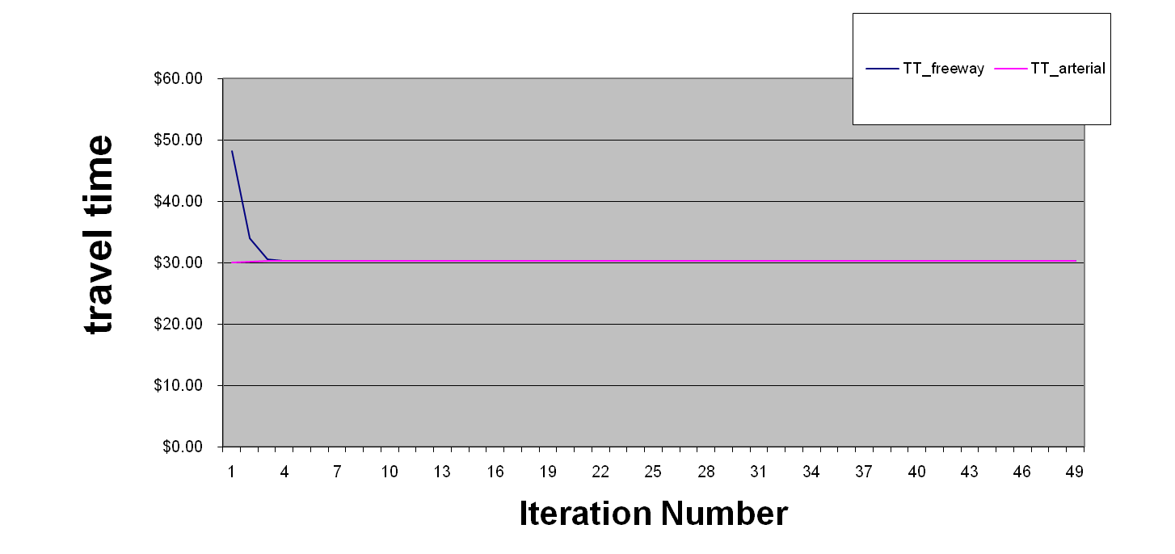

Figure 3 The variation of travel time on two links in the gradient projection algorithm

The meaning of each column in the "GP" spreadsheet is shown in Table 3 (the rows marked blue are related to the calculation process).

Table 2 The meaning of each column in the spreadsheet named "gradient projection"

|  |  |  |  |
| --- | --- | --- | --- |
| **Column name** | **Meaning** | | **Calculation** |
| Day (E) | Iteration number | Predetermined | |
| MSA step size (F) | Step size | 1/(E+1) | |
| Flow Frw (G) | The flow on freeway | Equation (8) | |
| Flow Art (H) | The flow on arterial | Equation (8) | |
| V/C Frw (I) | The ratio of flow to capacity on freeway | G/C1 | |
| V/C Art (J) | The ratio of flow to capacity on arterial | H/C2 | |
| TT_freeway (K) | The travel time on freeway | Cost function (1) | |
| TT_arterial (L) | The travel time on arterial | Cost function (1) | |
| TT_freeway_grad (M) | The gradient of travel time with respect to flow on freeway | The fist derivative of cost function (1) with respec to flow on freeway | |
| TT_art_grad (N) | The gradient of travel time with respect to flow on arterial | The fist derivative of cost function (1) with respec to flow on arterial | |
| TT_freeway_2ND_grad  (O) | The second derivative of travel time with respect to flow on freeway | The second derivative of cost function (1) with respec to flow on freeway | |
| TT_art _2ND_grad  (P) | The second derivative of travel time with respect to flow on arterial | The second derivative of cost function (1) with respec to flow on arterial | |
| Optimal (Q) | The minimum travel time on both links | MIN (K,L) | |
| Frw switch sign (R) | Whether travel time on freeway is minimum | If K=Q, it equals 1; otherwise, it equals -1 | |
| Art switch sign (S) | Whether travel time on arterial is minimum | If L=Q, it equals 1; otherwise, it equals -1 | |
| Frw_possible_switch (T) | The possible switch flow on freeway | If R=-1, it equals G;  Otherwise, it should euqals flow on arterial | |
| Art_possible_switch (U) | The possible switch flow on arterial | If S=-1, it equals H;  Otherwise, it should euqals flow on freeway | |
| Switched flow (V) | The real switched flow | MIN (F*q, T,U) | |
| Flow_on_non_optimal_path  (W) | The flow on non-optimal path | If , it equals  otherwise, it equals | |
| Relative Gap only (X) | The relative gap of travel time |  | |
| Relative Gap only (Y) |  | multiplying the flow on non-optimal path | |
| Gap (Z) | The absolute value of gap of travel time on both links |  | |
| Marginal (AA) |  | W*(M+N) | |
| Optimal_step_size (AB) |  | 1/(2M+2N+W(O+P)) | |
| Apporx_step_size (AC) |  | 1/(M+N) | |
| Frw switched flow (AD) | The switched flow on freeway | R*/(M+N) | |
| Art switched flow (AE) | The switched flow on arterial | -AD | |
| Frw new flow (AF) | The new flow on freeway | G+AD | |
| Art new flow (AG) | The new flow on arterial | H+AE | |
| Total flow (AH) | The total flow on both two links |  | |
| Avg travel time (AI) | Average travel time on both two links |  | |
| Gap (AJ) | The gap of travel time on nonptimal path | G(K-Q)+H(L-Q) | |

**2.3 Method of successive average**

**The algorithm description**

The algorithm of method of successive average can be summarized as follows:

step 0: *Initialization*. Perform all-or-nothing assignment based on . Obtain a set of link flows . Set iteration counter .

Step 1: *Update*. Set .

Step 2: Direction finding. New auxiliary link flows are calculated by performing all-or-nothing assignment according to the new travel time .

Step 3: *Move*.

 (9)

Step 4: *Convergence test*. Convergence test. If a convergence criterion is met, stop (the current solution , is the set of equilibrium flows); otherwise, set and go to step 1.

**Result analysis**

To approach the equilibrium flow pattern faster, let  in the spreadsheet named "msa".

One hundred iterations are calculated. The variation of travel time on freeway and arterial in the iteration process of this algorithm can be shown as the Figure 4.

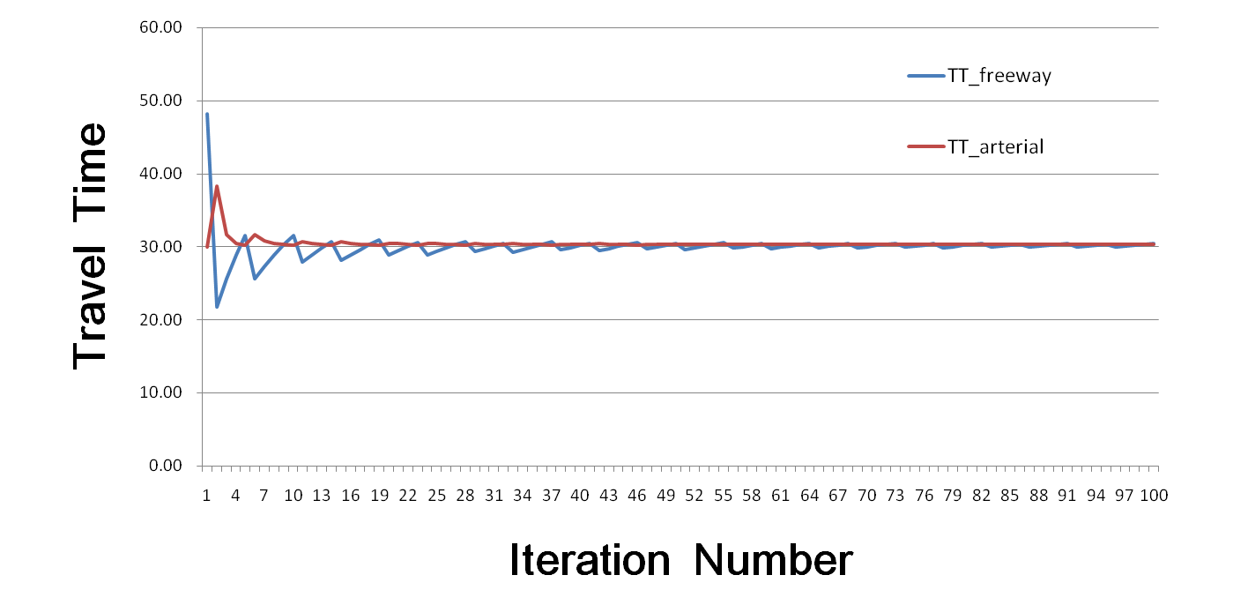

Figure 4 The variation of travel time on two links in the method of successive average

It can be found from the above figure that the convergence rate of the method of successive average is very slow. Though one hundred iterations are performed, the travel time on both two links still have some fluctuation. The main reason is that the new flow on each link is obtained by weighting average of the flow at the last iteration and the flow obtained by performing all-or-nothing assignment at this iteration. Although the value of is getting smaller and smaller with the iteration process, the effect of the flow after all-or-nothing assignment is still relatively significant.

**2.3 Gap comparison**

The convergence rate of each algorithm can be easily perceived by comparing the gaps in the iteration process. Here we compare gaps in the first fifty iterations obtained from method of successive average, algorithm in our TRB paper and gradient projection algorithm, which can be shown in Figure 5.

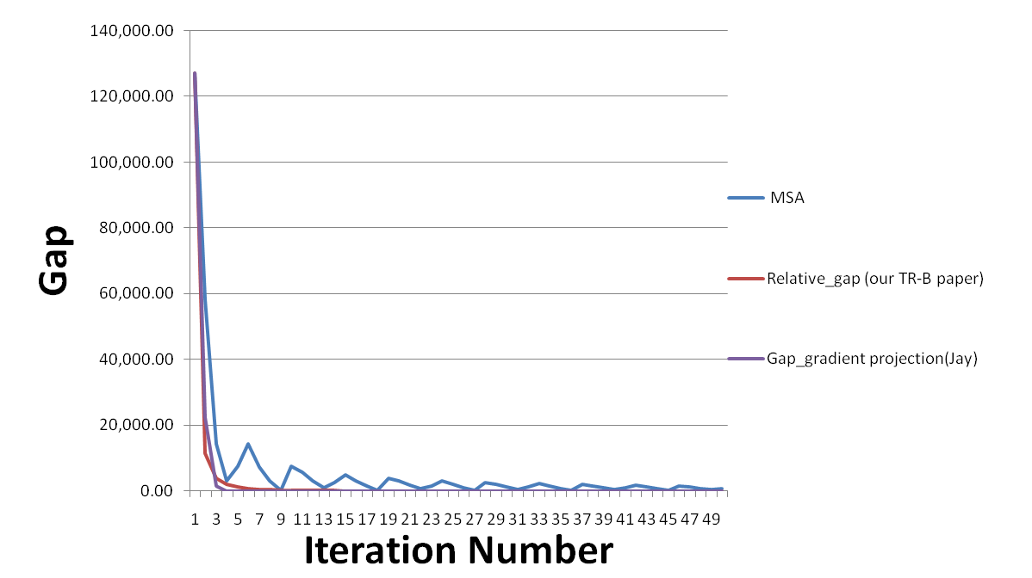

Figure 5 The comparison of gaps obtained from three algorithms

Some conclusions can be made from the Figure 5. The gradient projection has the most fast convergence rate, and its convergence criterion can be satisfied in the first five iterations. The gap is monotonous descent in the algorithm appeared in our TRB paper, though the rate is slower than the gradient projection. Whereas, the method of successive average not only has a very slow convergence rate but also the gap has some fluctuation. Fortunately, the fluctuation is more and more stable. However, the method of successive average can be performed easily.

Attention the F-W algorithm is not conducted here because the step of line search is hard to realize using spreadsheet.

**3 Simple traffic assignment**

Here we take the Braess network as an example to illustrate the traffic assignment process. The traffic assignment program used here can be written as:

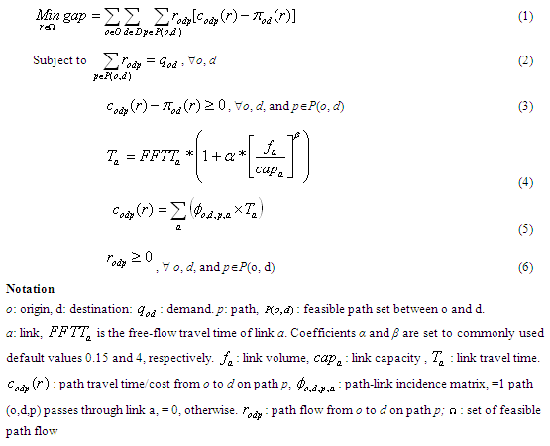

Figure 6 The traffic assignment program

The Braess network connected by three paths and five links is shown as Figure 7:



Figure 7 The Braess network structure

Thus the link-path-incidence matrix can be shown as:

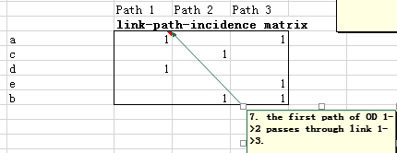

Figure 8 The link-path-incidence matrix

Firstly, we input the traffic attributes of each link as follows:

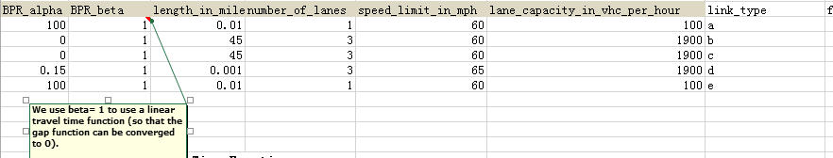

Figure 9 The traffic attributes of each link

Specially, the beta parameter appeared in the BPR cost function is set to 1 to make the gap function in the program linear so that it can converge to 0. The BPR link travel time function can be formulated as:



Figure 10 The BPR cost function

Now we can use the Solver function in spreadsheet to solve this problem. The network loading factor is input as follows:  
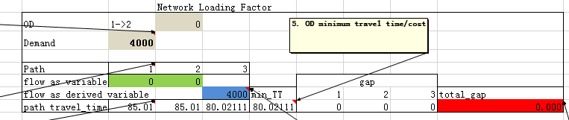

Figure 11 The network loading factor

In the figure 11, the red cell are designated as target cell, which displays the value of objective function. The green cell are variable cells displaying the value of variables appeared in the program, which represent the flows on paths 1 and 2, respectively. The blue cell represents the flow on path 3. Since it is not a variable of this program as other links, it was marked the different color from other paths. The constraint is set to assure the flows on each path positive. The solution interface using Solver function in spreadsheet can be seen as Figure 12:

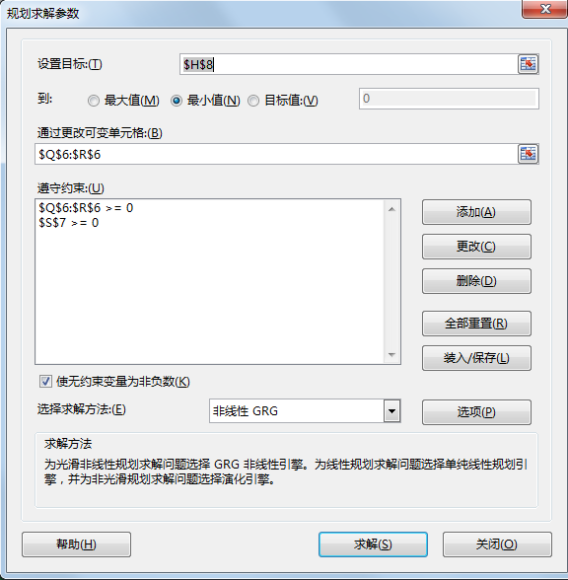

Figure 12 The solution interface using Solver function in spreadsheet

The result is shown in the Figure 11. The equilibrium path flow pattern is , and the value of objective function is 0. Thus, the paths flow pattern obtained in this program is real equilibrium flow pattern.

By using the following formula combing the link-path-incidence matrix,

 (11)

The flow on each link perceived can be seen as Figure 13.

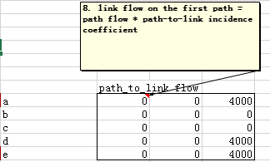

Figure 13 The flow on each link

Thus, the travel time on each link can be calculated according to BPR link travel time function. Attention, the travel time used in the Figure 14 represents the total travel cost , which includes not only the travel time but also road toll. The last column is the level of service on each link obtained by Figure 15.

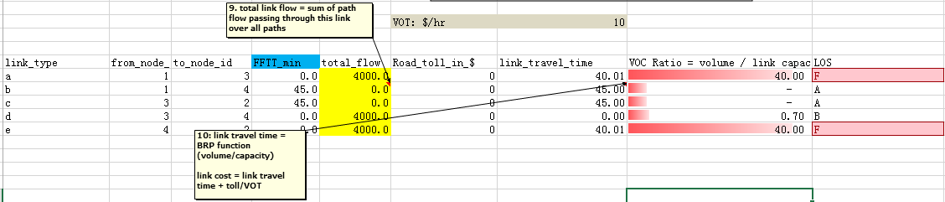

Figure 14 The flow, travel time, level of service of each link.

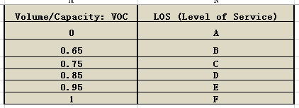

Figure 15 The level of service of each VOC

The travel time on each path can be calculated according to equation (5) in the program (Figure 6) displaying in Figure 11.

At the equilibrium state, the total travel demand 4000 are all assigned to path 3 connecting by three links a, e, b, which has the minimum travel time since the travel time on the other two links are larger than it. The minimum travel time equals 80.0211min.